Pathology classification analysis using multiple Deep Learning techniques

Aditya Shirude

Electronics and Telecommunication Engineering

Viswakarma Institute of Technology

Pune, India

aditya.shirude20@vit.edu

*Abstract*—***There is a need for automating the classification of huge pathological image data more accurately and efficiently in the medical sector. In this paper a proposed system of neural networks with Deep Belief Network for Image feature extraction and two different algorithms namely K Nearest Neighbors(KNN) and Transfer learning algorithm based on adaptive Support Vector Machine(SVM) to classify pathological images. The proposed system will provide a complete framework that is capable of processing graphical pathology images with better accuracy compared to traditional neural network algorithms. Using said methodology we can use a pre-trained model and use its weights to train on a different dataset with less epoch cycles. This will save computing costs and help make more accurate classifiers and predictive models.***

Keywords—*Deep neural network, SVM, CNN, Deep learning*

# Introduction

Over the previous few years, the speedy population growth has made early detection of

sickness is an essential topic in clinical studies. Many researchers have been capable of creating packages to come across and are expecting the use of open-source datasets that are made available with the aid of different healthcare institutes. Furthermore, next-technology sequencing has enabled researchers to dive deeply into the complicated info of biological systems which can be evaluated mathematically to create deep gaining knowledge of models extra correctly for class and selection purposes. The chance of loss of life from serious illnesses like cancer is growing exponentially because the population grows. A device that assists clinical personnel in sickness diagnosis, affords dependable, green, and fast response, and reduces the risk of fatalities. The proposed version is designed to enhance present day category and characteristic extraction methods in pathology photographs. The more recent transfer gaining knowledge of based technique has outperformed the traditional neural education techniques and is stated to be more correct in detecting the disorder at an advanced level. This study compares the accuracy of neural schooling strategies on various datasets to discover the satisfactory appropriate algorithm for the class of medical pix. This observes additionally objectives to automate the classification method of the pathology photographs generated by the scientific institutes more correctly in comparison to the traditional CNN strategies with the aid of using an Adaptive guide Vector device-primarily based on gaining knowledge of a pre-trained model to improve the results of the newly trained model.

# Literature Review

1. The purposed paper summarized the different ways in which AI-based cancer prediction models could go. There is space for progress in the early detection of head and neck cancers, as there has been little study done on these two malignancies due to a lack of data sets.
2. Proposed that the accuracy of voice pathology systems is commonly utilized as an important criterion for evaluating them. As a result, the researchers employed this performance evaluation in this work to compare the proposed OSELM model to current methods in vocal pathology systems that also utilized SVD voice samples.
3. In the proposed study, the Deep Belief Network, a new patch-based deep learning algorithm, is utilized to detect and categorize breast cancer on histopathology images (DBN). By creating equal-sized patches of pictures, the recommended model learns the Properties automatically. This reduces the computing cost while also increasing the accuracy of binary categorization.
4. Proposed a framework for histopathology photo categorization based on self-supervision tasks to solve the issue of restricted annotations in the field of computational pathology. Despite being simple and easy to implement, the data show that pathology-specific tasks can outperform generative approaches.
5. proposed study that mainly incorporates proposed machine learning algorithms based on microarray and NGS data. Further research could focus on how microRNAs can help in cancer diagnosis and prognosis.
6. The said work proposed a single framework for combining radiology and pathology imaging. Regions of interest in pathology and radiology images are separated to allow extracting unique features easier. In this study, pictures for radiology and pathology are processed utilizing a separate image processing pipeline. The photos are gathered, and the task-specific structures are extracted. It is then fed into a pre-trained version of Inception v3 for the extraction of high-level complicated feature descriptors.
7. Proposed the work in which the DNN was used to segment cancer nodules using three-dimensional CT images. As the amount of training data increases, DNN's efficiency improves. It may be utilized to segment microscopic lung nodules and has an enhanced accuracy of 0.8119.
8. In this proposed work deep learning-based segmentation algorithms are used because of their ability to self-learn over enormous volumes of data. To help with diagnosis and other assessments, segment the various tissues in an MR picture of a brain tumor. There is a need for automated image segmentation of brain tumors because this manual technique is challenging and time-consuming.
9. The proposed Deep neural networks have been demonstrated to correctly classify gliomas up to 94% of the time. Deep learning algorithms for MRI brain registration are still in the early phases of development, and there is no consensus on the best methods. Despite the fact that segmentation is gaining popularity, it still suffers from a shortage of sufficient training data as well as uneven data.
10. The proposed research uses traditional logistic regression, multi-factor analysis, and AI-assisted analysis. Deep learning-based cancer detection algorithms are being researched. These strategies have an impact on cancer diagnosis methods and serve as a resource for doctors.
11. The proposed work intended to develop a convolutional neural network for detecting lung cancers in chest X-ray images. 225 techniques were utilized to compare the results of the aforementioned CNN network with those of other approaches such as MLP and SVM.
12. The proposed study intends to use attribute selection techniques and classifiers models on the Immunotherapy dataset. They discovered that while the classifier model performed poorly on raw data, it performed exceptionally well on the attribute selection processed model.

#### This paper presents two efficient deep transfer-learning-based models that rely on pre-trained CNNs and a wide set of ImageNet datasets. In multiclass classification, the suggested system obtained up to 98 percent accuracy, while in binary classification, it achieved 100 percent accuracy.

1. The study proposes an automatic illness detection system that can aid medical staff by delivering a dependable, effective, and efficient approach while also lowering the risk of disease-related death. ANNs have the highest accuracy of 98.57 percent, while RFs and LR have the lowest accuracy of 95.7 percent.
2. The proposed work suggests a new approach for extracting features from CT pathological images of the brain, chest and classifying them. For photo classification, a semi-supervised learning strategy is proposed. Counter neural networks beat other neural networks and traditional classification methods by 10%, and the advantages are more obvious.
3. The proposed work used deep learning-based segmentation algorithms because of their ability to self-learn over enormous volumes of data. Combining a deep neural network with a probabilistic neural network to detect brain cancers. The model used CNN and PNN algorithms to create a two-way path.
4. The proposed work uses transfer learning methodologies for transferring CNN model knowledge for clinical data extraction from cancer pathology reports. Investigated in proposed study. The study focuses on primary cancer sites and topography data extraction, which is a critical task for cancer registries.
5. Proposed the improved deep convolutional neural network for breasts before and after compression. The distorted model was correlated by the ADCNN. In this proposed work compression forces were applied. Before and after compression, get the upgraded deep convolutional neural network for breasts.
6. This proposed model suggested that calculated accuracy can be improved by expanding the dataset, which the researchers did here by including mass-circularity measurement in the dataset, and we discovered from statistical analysis that this quantitative measurement contributes to transparency in our conclusion.
7. Three CNN models VGG16, ResNet50, and Inception v3 are trained on ImageNet in this proposed study. Instead, we look at the significance of transfer learning. 98.23% of MIAS photos, 97.35% of DDSM images, 95.50% of INbreast images, and 96.67% of BCDR images were properly classified using the suggested framework. The model could be fine-tuned for more sophisticated pathological visual classification in the future.

Literature Review Table

|  |  |  |  |  |
| --- | --- | --- | --- | --- |
| Sr No | Summary | Datasets | Methodology/Algorithm | Challenges and Discussion |
| [1] 2021 | This Study compares different Deep Neural Network-based techniques that are used to classify pathological images and compares different methodologies with Traditional CNN etc. | the web of science  EBSCO  EMBASE. | This study compares different methods used in computational pathology like:  Convolutional Neural Networks   * Deep Neural Networks | The purpose of this review is to summarize the various directions for AI-based cancer prediction models. On that basis it concludes that only a few data sets have been explored so far for these two types of cancer, there is room to work on early detection of head and neck cancers. |
| [2] 2021 | In this analysis of voice disorders, machine learning algorithms are crucial for semi-vocal disease diagnosis utilizing only an audio signal. Despite this, most modern vocal pathology systems rely on a small acoustic database. In other words, the audio signal is analyzed using only one vowel, such as /a/, whereas phrases and other vowels are ignored. | SVD (Saarbrucken Voice Database) | * Mel Frequency Cepstral Coefficients (MFCC) * Online Sequential Extreme Learning Machine algorithm | The proposed work showed improved accuracy in detection and less execution time. As a result of the said research, it can be concluded that further work such as tuning the OLSEM classifier and selecting efficient weights is needed. |
| [3] 2021 | The suggested model automatically learns the characteristics by generating equal-sized patches of photos. This lowers the computational cost while also improving binary classification accuracy. |  | * Multi-layer perceptron (MLP) neural network * Deep Belief Network | The proposed model has higher gpu overhead and is very extensive in terms of hardware requirements.  The proposed methodology cannot classify different types of cancers as it uses binary classifiers. |
| [4] 2021 | For this work convolutional neural networks with self-supervised learning Deep learning algorithms are being used in cancer diagnosis, specifically in CT/MR brain and abdomen imaging, mammography images, histopathological images, and diabetic retinopathy detection. Using unlabeled data, convolutional neural networks (CNNs) are utilized to learn generalizable and domain-invariant representations for pathological images. The key objective in this system, named Self-Path, is tissue classification. | r Camelyon16 Challenge Dataset,  LNM-OSCC Dataset,  Kather Dataset | The model is trained using a strategy that combines the main and pretext tasks. A shared encoder is included in the framework, which learns aspects that are common to both the pretext and primary tasks. Each job usually has its own head connected to the common Encoder, and learning is optimized for all tasks at the same time. | One of the drawbacks of the study is that the direction may have used alternative self-supervision tasks, such as forecasting the Eosin channel or a combination of Hematoxylin and Eosin after estimating the two channels instead of keeping them constant and expanding the jigmag grids to include larger and more complex puzzles for the network to solve |
| [5] 2021 | This study does analysis of different methods and techniques and how different researchers were able to design algorithms that aid in the early identification and prognosis of diseases thanks to artificial intelligence. Next-generation sequencing has aided in delving deeper into the complexities of biological systems. It has given a more accurate, efficient, and cost-effective technique. | UCI repository, Breast cancer dataset | The study did a comparative analysis of various standard algorithms and generic methods used in machine learning techniques.   * CNN * DNN | Instead of making a model based on microarray using microRNAs, they play a critical function in regulating the posttranslational regulation of coding genes and may increase efficiency. |
| [6] 2021 | In this work the images for radiology and pathology are processed using a distinct image processing pipeline.  A single framework for merging radiology and pathology imaging is being investigated in this study.  To make it easier to extract unique information from pathology and radiology pictures, regions of interest are divided. | Dataset was taken from 2018 MICCAI challenge. | In this proposed study, pictures for radiology and pathology are processed utilizing a separate image processing pipeline. The photos are gathered, and the task-specific structures are extracted. It is then fed into a pre-trained version of Inception v3 for the extraction of high-level complicated feature descriptors. | Further efficiency can be achieved by dimensionality reduction techniques and eliminating features and co-relations. |
| [7] 2020 | Application of deep learning algorithms to cancer diagnosis, specifically in CT/MR brain and abdomen images, mammogram images, histopathological images, and the detection of diabetic retinopathy. | The dataset was provided by Nanyang Technological University | A multi-scale neural network with three convolution layers, a rectified linear unit, and a max-pooling layer, as well as two fully linked layers, is known as a convolution neural network. Before being sent to the neural network, the input image is down-sampled and feature extraction is performed. | On 3D CT images, the DNN was found to be efficient for segmenting cancer nodules. The DNN becomes more efficient as training data increases. It is accurate to 0.8119 and can segment small lung nodules.  Higher accuracy can be achieved using transfer learning and making use of a pre-trained model. |
| [8] 2020 | The proposed work makes use of deep learning's ability to self-learn from massive volumes of data, and artificial intelligence approaches for the clinical diagnosis of brain tumors are becoming increasingly popular. Deep learning is a very promising and efficient method for producing a clinical diagnosis solution. | MICCAI BraTS:  T1-weightedT2-weightedT1CE-weighted  FLAIR | The proposed study used different deep learning methodologies and algorithms (like DCNNs, LTSM) and analyzed their pros and cons to draw suitable conclusions. | The said methodology requires vast data for which higher GPU computation is required.  The use of computer-aided systems in diagnostics has had a significant impact. |
| [9] 2020 | Deep neural networks have been shown to accurately classify gliomas with up to 94% accuracy. To segment the various tissues in an MR image of a brain tumor to help with diagnosis and other assessments. Since the process is laborious and time-consuming, there is a need for automated image classification of brain related tumors. | BRATS dataset of MRI scans | The study makes use of DLTE and similar deep learning-based techniques to create MRI brain tumor classifier. | The proposed Deep learning techniques for MRI Brain registration are still in their early stages, and there is no consensus on the optimal methods. Although segmentation has gotten increasing attention, it still suffers from a lack of appropriate training data as well as data that is unbalanced. |
| [10] 2020 | The proposed study will employ traditional logistic regression, multi-factor analysis, and artificial intelligence-assisted analysis. |  | The study does comparative analysis on the following techniques (like CNN, RNN, DBM, DBN) and methodologies:  Deep Neural Networks (DNN) | The application of deep learning algorithms for cancer diagnosis is being investigated. These strategies lead to a shift in cancer diagnosis methods and serve as a support tool for clinicians. It has been discovered that it delivers significant advances in a critical issue like cancer treatment. |
| [11] 2020 | The proposed study focuses on determining if a suspicious spot is a nodule or not using a convolutional neural network. The JSRT digital images of chest X-ray database was established by the Japanese Society of Radiological Technology (JSRT). | Chest X-ray images from the medical institute | * MLP Network * Architecture * CNN Network Architecture * Support Vector Machine | The major goal of this proposed study was to create a convolutional neural network for detecting lung tumors in X-ray pictures of the chest. To compare the results of the aforesaid CNN network with other approaches such as MLP and SVM, 225 approaches were used. |
| [12] 2020 | Using attribute selection techniques and classifier models on the Immunotherapy dataset.  They observed that the classifier model worked comparatively less accurately on raw data but the same model showed very good results on the attribute selection processed model. | Breast Cancer Coimbra data sets | * Random Forest technique * SVM * RNN * CNN | Further study on this model can help in analyzing the big data more efficiently.  RNN models can be used as a health tool for better and faster classification results on medical images. |
| [13] 2020 | The paper proposes two effective deep transfer-learning-based models that rely on pre-trained CNNs and a wide set of ImageNet datasets. In multiclass classification, the suggested system obtained up to 98 percent accuracy, while in binary classification, it achieved 100 percent accuracy. | ImageNet dataset  BreakHis dataset | * Transfer Learning * CNN Network | The proposed models worked less accurately in the 400x images.  So investigating low accuracy for the 400x image could be another future task for this proposed work. |
| [14] 2020 | The study proposes an automatic disease detection system can assist medical personnel by providing a reliable, effective, and efficient approach, as well as decreasing the risk of disease-related death. | Dataset was used from UCI repository | The study did a comparative analysis of the following algorithms:   * SVM * KNN * Random Forests * Logistic Regression | The best accuracy is achieved by ANNs, which is 98.57 percent, while the lowest accuracy is achieved by RFs and LR, which is 95.7 percent. This concept claims that machine learning can be utilized as a clinical assistant in the identification of breast cancer because medical diagnostics is both costly and time-consuming. |
| [15] 2020 | This study proposes a new approach for extracting features from CT pathological pictures of the brain and chest and classifying them has been developed. For picture classification, a semi-supervised learning approach is proposed. It trains the network model with a small amount of tagged pathological image data before incorporating the network's characteristics to categorise the image. | The photos used in this investigation came from a hospital's data centre. There are 12000 CT scans of the brain, chest, and cervical spine in the database. | * Support Vector Machine * Convoluted Neural Networks(CNN)   This said method uses a semi-supervised learning approach for | Counter neural networks outperform different neural networks algorithms and standard classification methods by 10%, and the benefits are more visible. Comparative investigations confirm the classification model's logic and validity, resulting in a revolutionary medical picture classification concept. |
| [16] 2020 | Combining a deep neural network with a multilayer perceptron, deep learning is utilized to detect undesirable masses in the brain. Tumors can form anywhere in the brain, and their characteristics, such as shape, contrast, and size, have remained a mystery. | Open Source MICCAI and SMIR repositories | * Convolutional Neural Network(CNN) * Probabilistic neural network( PNN) | Researchers at the University of Bristol assessed the output segmented image, as well as the accuracy and loss of the models.  According to them, the two paths CNN architecture showed better accuracy compared to other methodologies. |
| [17] 2019 | The proposed research involves analysing textual information taken from cancer pathology reports to aid in national cancer surveillance. The researchers sought to see if using a convolutional neural network for transfer learning may help with cross-registry knowledge sharing. | Independent SEER program sources; the Louisiana Tumor Registry (LA), and Kentucky Cancer Registry (KY) | * Natural language processing | This model is not generalized to classify between 2 different cancer registries even after freezing the parameters.  The study focuses on primary cancer locations and the extraction of topography information, which is a crucial task for cancer registries.  Several Transfer Learning techniques for transferring CNN model knowledge for clinical data extraction from cancer pathology reports are investigated in this paper. |
| [18] 2019 | In this proposed work compression forces were applied. Before and after compression, get the upgraded deep convolutional neural network for breasts.  The ADCNN produced a correlation of the distorted model. |  | * Multi-aspect deep convolutional neural network * Finite segment model * Recurrent neural system | The proposed framework was able to show accuracy of 87.5%.  Higher sensitivity was noted with the help of the proposed model with improvements upto 20 percent. |
| [19] 2019 | To tackle the issue of Breast Cancer among women and create a model for efficient early detection and classification the proposed work ought to use Deep learning approaches for efficient results. Deep learning is considered a major and important technique in the field of categorization in recent years. In medical needs, the classification algorithm still has a lot of clouts, especially if it's combined with deep learning. | The data was provided from the Medical Center University's Institute of Oncology in Ljublijana, Yugoslavia. | * Multilayer Perceptron * Convolutional Neural Networks(CNN) | This accuracy can be improved by expanding the dataset, as did here by including mass-circularity measurement. |
| [20] 2018 | Three CNN models VGG16, ResNet50, and Inception v3, are trained on ImageNet in this proposed study. Instead, we look at the significance of transfer learning. | Three different public datasets were used  The three datasets were then merged into one dataset | * Global Contrast Normalization * ROI Extraction * Transfer Learning | More difficult images show less accurate results. Using deeper models can solve this problem.  The proposed framework correctly diagnosed 98.23 percent of MIAS photos, 97.35 percent of DDSM images, 95.50 percent of INbreast images, and 96.67 percent of BCDR images.  Future work could involve fine tuning the model for more complex pathological visual classification. |

# Methodology

* *Data acquisition:-*

We will be using Kaggle Dataset for this training and testing of the model with weights from the pretrained model of VGG16 model.

Image Pre-processing:-The images will be re-sized and blurred using multiple pre-processing techniques to make them more standardized which will make testing and training easier. Vgg16 takes an image of Dimension 224 x 224 x 3. CNN model takes input image size of 200 x 200 x 3.

* *Algorithm implementation :-*

Using a pretrained model from Vgg16 we will use transfer learning technique to train it on our dataset. This method will reduce the total trainable parameters like in this case a total of 14,764,866 total parameters were reduced to

50,178. That will help in reducing the epoch cycles significantly and will reduce the hardware overhead. The comparison dispersion algorithm is used to update the training parameters after each parameter has been initialized and the training period and learning rate have been determined. If the method converges, the outcome will be displayed; otherwise, the parameter training will continue while the equation is solved.

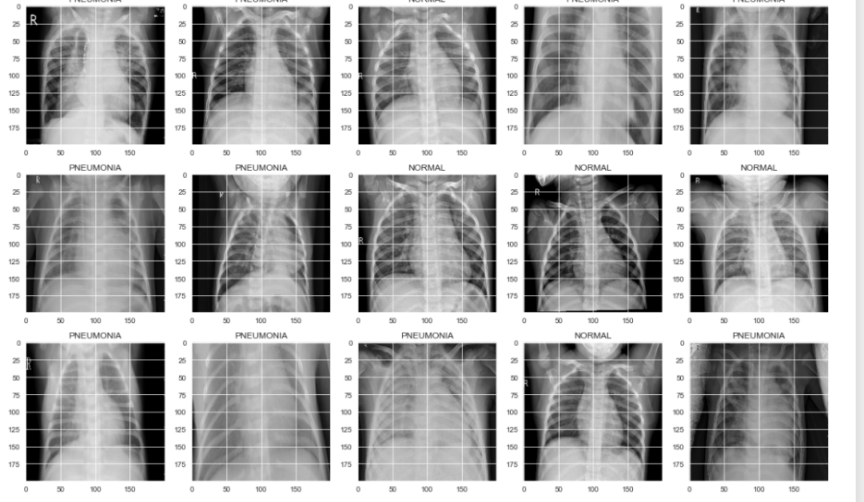

Fig(1). Head of the Kaggle dataset. Lung disease dataset from Kaggle.

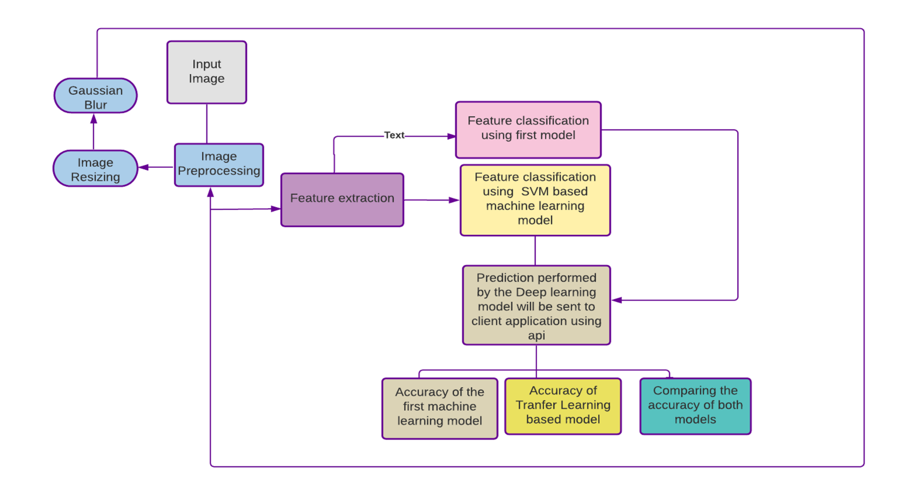

Fig(2). Working Flowchart of the proposed framework in block diagram form. The flowchart represents the working of the said algorithm in different phases.

* *Classification of Images:-*

Classification of images will be done by two different models based on different algorithms.

1)For the first model we will use Transfer learning (TL) which is a machine learning (ML) research method that works by storing the results of particular data and then using the stored data to find the solution to related but different problems. For this method a pre-trained model is required which will then be retrained for classifying different Datasets. The advantage of using transfer learning is that we already have a pre-trained dataset and retraining will take less number of epochs for achieving higher accuracy levels. This will save a considerable amount of computational power and result in a more efficient model. Using said methodology we can use a pre-trained model and use its weights to train on a different dataset with less epoch cycles. This will save computing costs and help make more accurate classifiers and predictive models.

2)The second model uses supervised machine learning, where H. is taught by recording the input X and the label Y, and then learning how to map input X to output Y. Using this method, we can arrange the images in 2D vector space, calculate their distance between each other, and then sort them. We now will pick up the minimum distance and assign them a label. The results produced by the models will be compared on a scale of 0 to 1 for accuracy.

1. The first model will use the state of the art framework to train the dataset. We will use “adam” as an optimizer. The model will predict categorical variables. The Transfer learning model will intake the input as 224 by 224 as the VGG16 was made in such a way. The second model will be a CNN based which makes use of the Sklearn package of Python and also a categorical variable predictor.

# Results

The Transfer learning model showed an accuracy of accuracy: 0.9714 total of 5 epoch cycles. The model showed significantly improved results in reducing the computational overhead and giving so much accurate results.

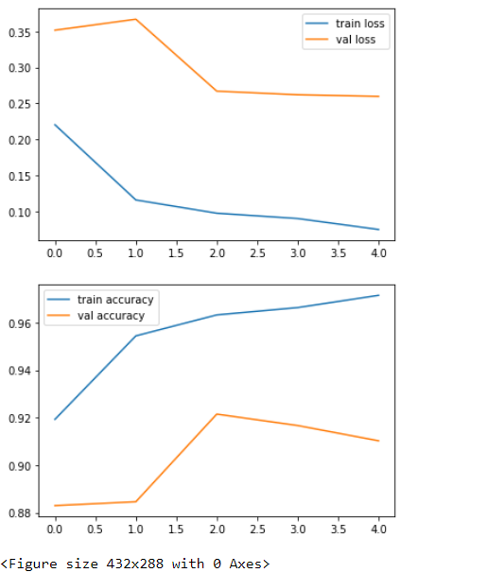

Fig(3). Plot of val accuracy, val loss,

train accuracy, train loss.

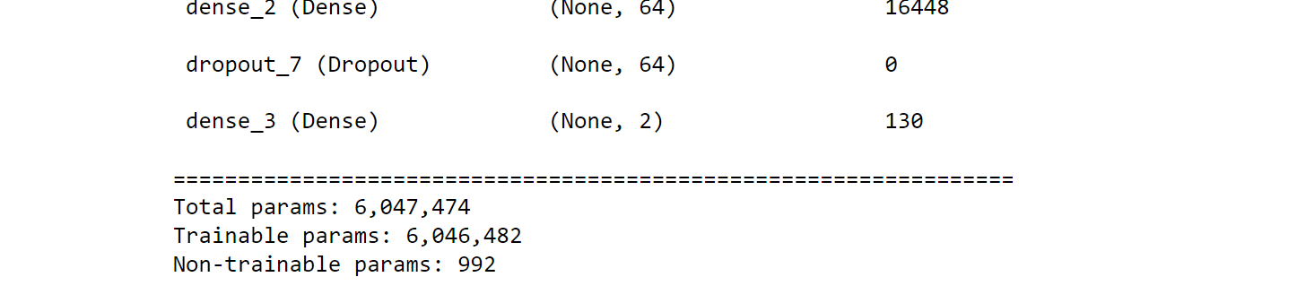

Fig(4). Parameters of TL Model

The CNN model showed an accuracy of 77.24 percent in 20 epoch cycles. With over 600000 parameters to train it took quite a bit of hardware power to train it in a relatively high number of epoch cycles.

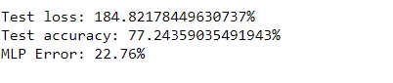

Fig(5) Accuracy of CNN model

# CONCLUSION:

As shown in results the Transfer Learning Model showed an accuracy of 97.14 percent or 0.9714. The accuracy of CNN Model was 77.24 as shown in results in 20 epoch cycles. The proposed paper is still in its early stages and as the current technology progresses there will be many different ways to approach this kind of data more efficiently. The further improvement in hardware can also be a very useful step in increasing the accuracy and reducing the time complexity for training such models. The pathology images are very important for the detection of fatal diseases and disorders. And therefore it is very important to have an automated efficient system that can be used for such tasks.

To tackle the ever-increasing demand for a computationally efficient and accurate framework that can cope with the ever-increasing pathological image that is produced in recent times the proposed model intends to create a structured framework. The proposed model uses the Support Vector Based Transfer Learning model for more accurate results compared to the traditional CNN methods and techniques. To check and analyze the efficiency of the model we compared it with a traditional CNN classifying method.

# FUTURE SCOPE:

Implementing the pre-trained model to predict more complicated medical imagery like tumor prediction from CT-scan images. The model can be trained so that it can be used to precisely locate possible tumor growth to catch the disease in very early stages. The scope of computer vision combined with deep learning is very vast and can be only explored if we make new and more innovative techniques from current available architecture.

##### References

1. Kumar, S. N., Fred, A. L., Padmanabhan, P., Gulyas, B., Kumar, H. A., & Miriam, L. J. (2021). Deep Learning Algorithms in Medical Image Processing for Cancer Diagnosis: Overview, Challenges and Future. *Deep Learning for Cancer Diagnosis*, 37-66.
2. Al-Dhief, F. T., Baki, M. M., Latiff, N. M. A. A., Malik, N. N. N. A., Salim, N. S., Albader, M. A. A., ... & Mohammed, M. A. (2021). Voice Pathology Detection and Classification by Adopting Online Sequential Extreme Learning Machine. *IEEE Access*, *9*, 77293-77306.
3. Hirra, I., Ahmad, M., Hussain, A., Ashraf, M. U., Saeed, I. A., Qadri, S. F., … Alfakeeh, A. S. (2021). Breast Cancer Classification From Histopathological Images Using Patch-Based Deep Learning Modeling. IEEE Access, 9, 24273– 24287.
4. Koohbanani, N. A., Unnikrishnan, B., Khurram, S. A., Krishnaswamy, P., & Rajpoot, N. (2021). Self-Path: Self-supervision for Classification of Pathology Images with Limited Annotations. *IEEE Transactions on Medical Imaging*.Self-Path: Self-supervision for Classification of Pathology Images with Limited Annotations. IEEE Transactions on Medical Imaging.
5. Sharma, A., & Rani, R. (2021). A Systematic Review of Applications of Machine Learning in Cancer Prediction and Diagnosis. *Archives of Computational Methods in Engineering*, 1-22.
6. Rajalakshmi, N. R., Sangeetha, B., Vidhyapriya, R., & Ramesh, N. (2021). Combined Radiology and Pathology Based Classification of Tumor Types. In Deep Learning for Cancer Diagnosis (pp. 99-109). Springer, Singapore.
7. Kumar, S. N., Fred, A. L., Padmanabhan, P., Gulyas, B., Kumar, H. A., & Miriam, L. J. (2021). Deep Learning Algorithms in Medical Image Processing for Cancer Diagnosis: Overview, Challenges and Future. *Deep Learning for Cancer Diagnosis*, 37-66.
8. Munir, K., Frezza, F., & Rizzi, A. (2021). Deep Learning for Brain Tumor Segmentation. In *Deep Learning for Cancer Diagnosis* (pp. 189-201). Springer, Singapore.
9. Healy, J. J., Curran, K. M., & Trbalic, A. S. (2021). Deep Learning for Magnetic Resonance Images of Gliomas. In *Deep Learning for Cancer Diagnosis* (pp. 269-300). Springer, Singapore.
10. Calp, M. H. (2021). Use of Deep Learning Approaches in Cancer Diagnosis. In *Deep Learning for Cancer Diagnosis* (pp. 249-267). Springer, Singapore.
11. Deepal, D. A. A., & Fernando, T. G. I. (2021). Convolutional Neural Network Approach for the Detection of Lung Cancers in Chest X-Ray Images. In *Deep Learning for Cancer Diagnosis* (pp. 203-226). Springer, Singapore.
12. Basarslan, M. S., & Kayaalp, F. (2021). Performance evaluation of classification algorithms on diagnosis of breast cancer and skin disease. In *Deep Learning for Cancer Diagnosis* (pp. 27-35). Springer, Singapore.
13. Yari, Y., Nguyen, T. V., & Nguyen, H. T. (2020). Deep learning applied for histological diagnosis of breast cancer. *IEEE Access*, *8*, 162432-162448.
14. Islam, M. M., Haque, M. R., Iqbal, H., Hasan, M. M., Hasan, M., & Kabir, M. N. (2020). Breast cancer prediction: a comparative study using machine learning techniques. SN Computer Science, 1(5), 1-14.
15. Tang, H., & Hu, Z. (2020). Research on medical image classification based on machine learning. IEEE Access, 8, 93145-93154.
16. Madhupriya, G., Guru, N. M., Praveen, S., & Nivetha, B. (2019). Brain Tumor Segmentation with Deep  Learning Technique. 2019 3rd International Conference on Trends in Electronics and Informatics (ICOEI)
17. Alawad, M., Gao, S., Qiu, J., Schaefferkoetter, N., Hinkle, J. D., Yoon, H. J., ... & Tourassi, G. (2019, May). Deep transfer learning across cancer registries for information extraction from pathology reports. In 2019 IEEE EMBS International Conference on Biomedical & Health Informatics (BHI) (pp. 1-4). IEEE.
18. Ahmed, S. R. A., UÇAN, O. N., Duru, A. D., & Bayat, O. (2018). Breast cancer detection and image   evaluation using augmented deep convolutional neural networks. *Aurum journal of engineering systems and architecture*, *2*(2), 121-129.
19. Nurmaini, S., Malik, R. F., Abidin, D. Z., Zarkasi, A., & Kunang, Y. N. (2018, October). Breast cancer classification using deep learning. In *2018 International Conference on Electrical Engineering and Computer Science (ICECOS)* (pp. 237-242). IEEE.
20. Chougrad, H., Zouaki, H., & Alheyane, O. (2018). Deep convolutional neural networks for breast cancer screening. *Computer methods and programs in biomedicine*, *157*, 19-30.